Experiment no-10
StyleHub online fashion shopping website
AIM:
To develop an online fashion shopping website using HTML, CSS, and JavaScript to browse clothing, footwear, and accessories by category and size. The system allows users to search products, add items to the cart, place orders, and track deliveries.
Procedure:
- Create an HTML page to display clothing and accessories.
- Add product categories and price options.
- Apply CSS to style the webpage.
- Use JavaScript to select products and display their prices.
- Display the selected product and order message.
Sample Code:
<!DOCTYPE html>
<html>
<body>
<h2>Online Fashion Shopping</h2>
<select id="item">
<option value="800">Shirt - Rs.800</option>
<option value="1200">Jeans - Rs.1200</option>
<option value="1500">Shoes - Rs.1500</option>
</select>
<button onclick="buy()">Add to Cart</button>
<p id="result"></p>
<script>
function buy() {
let i = document.getElementById("item");
document.getElementById("result").innerHTML =
i.options[i.selectedIndex].text +
" added to cart. Price: Rs." + i.value;
}
</script>
</body>
</html>

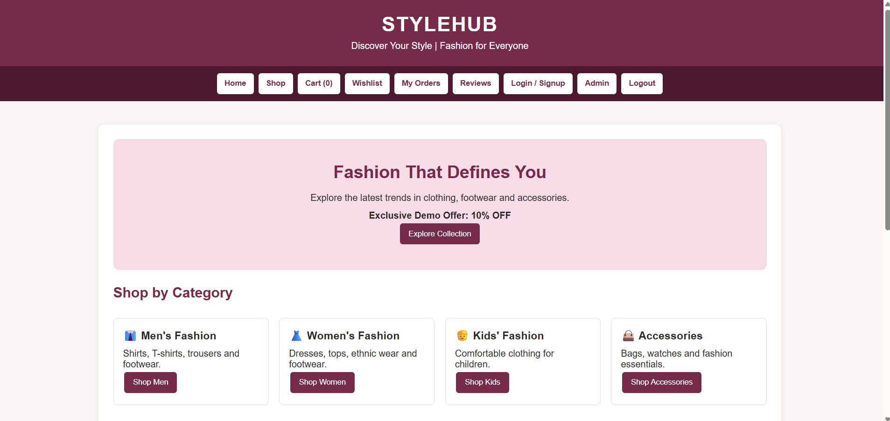
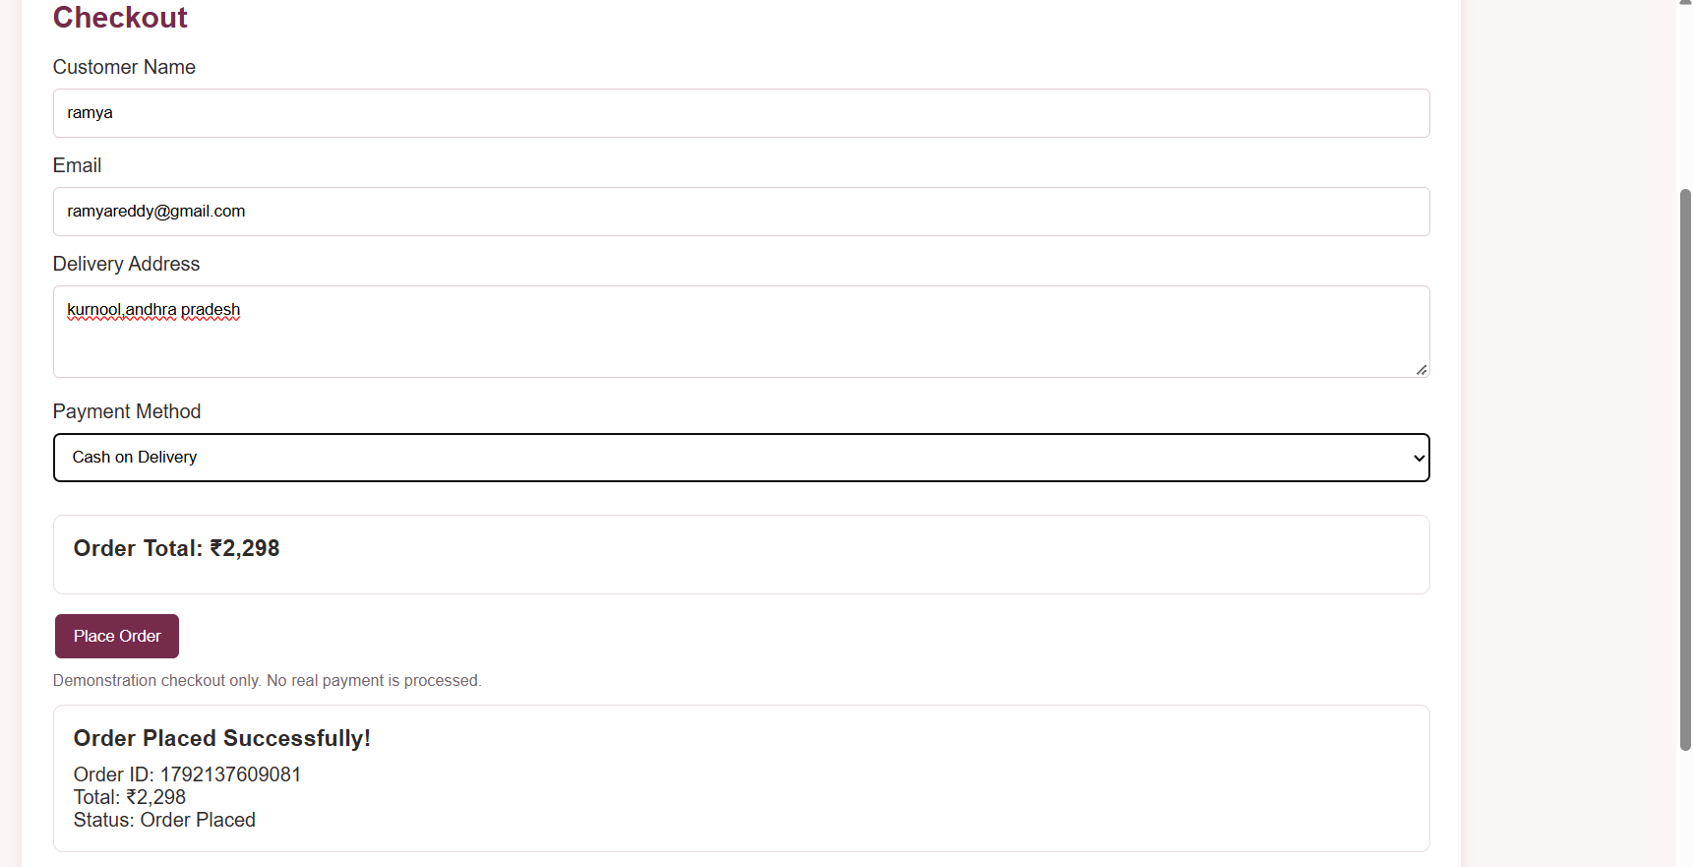
Result:
Thus, the online fashion shopping website was developed successfully to select fashion items, display prices, and show the cart confirmation.

